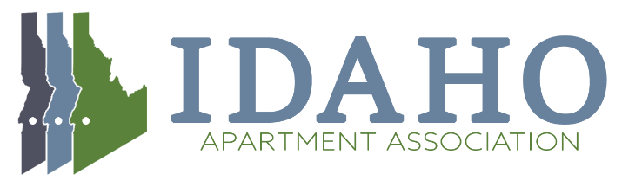
Government Affairs Committee Agenda
October 28th, 2021 10:00 AM

- Welcome and Introductions
- Discuss the Rent/Fee/Deposit Control Prohibition Statute – Update on progress
- PAC Fundraising Event 1st Quarter Update
- Additional Business

NEXT MEETING: Nov 18th, 2021 10 AM

